Coppull Medical Practice
Patient Satisfaction Survey 2025/2026
Each year we conduct a patient survey. This is to allow us to review the service we are providing and give patients an oppotunity to feedback on the service they have received. We conducted the survey in the surgery waiting room in March 2026, however the number of forms completed were insufficient, so we also conducted a text survey in May 2026. The results have been combined and presented in the following charts.
The results of this survey will be shared with our practice team and our patient participation group.
Results:
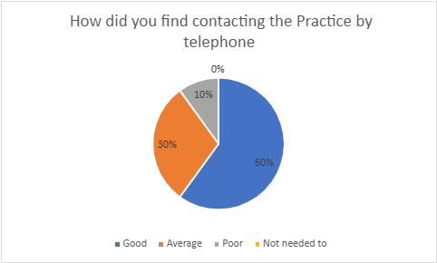

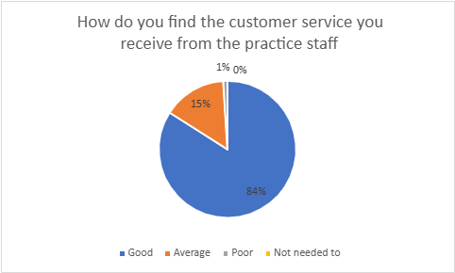
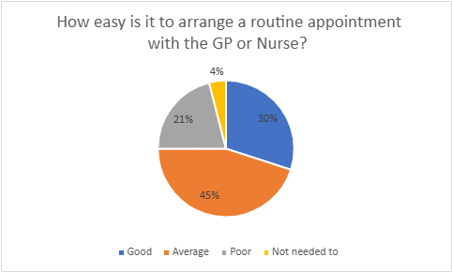

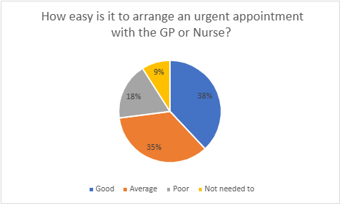

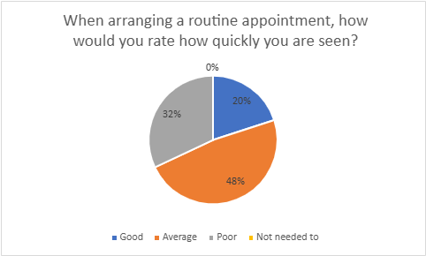

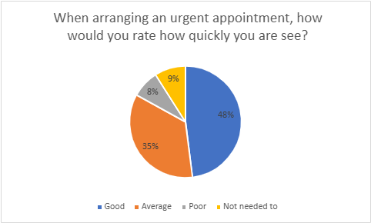

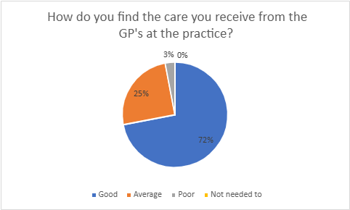

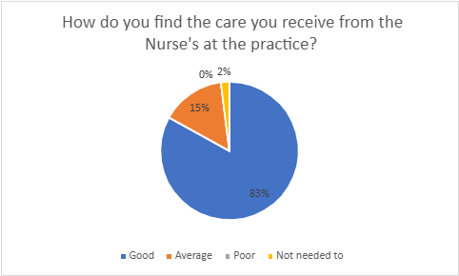
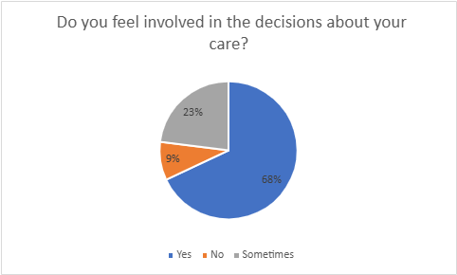

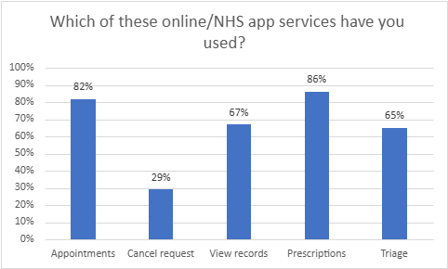

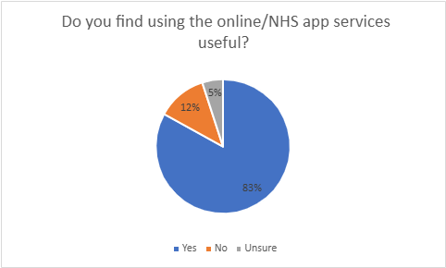

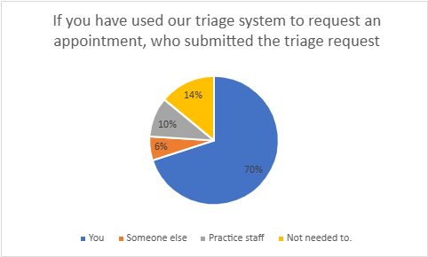

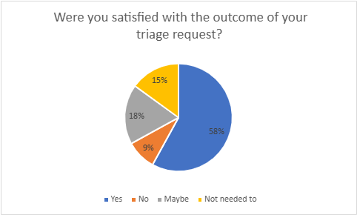

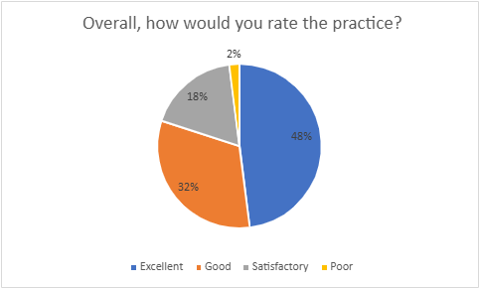

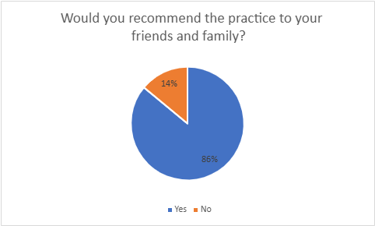

Conclusion:
We have noted that the majority of patients do rate the practice as excellent or good and would recommend the practice to their friends and family. Satisfaction rates around customer service and care is also good. We did note that there is a degree of dissatisfaction with routine appointment waiting times. We have looked into this further, as we are aware there have been changes within the practice in the last 12 months with regards to GP’s retiring.
The following charts show the practice appointment data with regards to the number of appointments available for patients to book.

The practice has two types of routine appointments:

1. Green - these are appointments for patients with a routine medical issue that is clinically safe to wait to be assessed. These appointments can be booked a number of weeks in advance.

2. Amber – these are appointments for patients who do not need an urgent appointment but do need to be seen within the next 10 days.

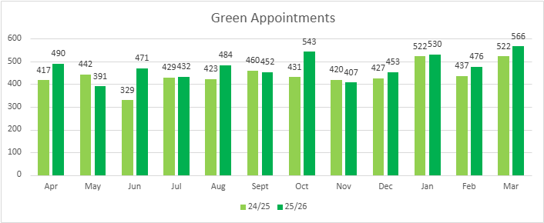

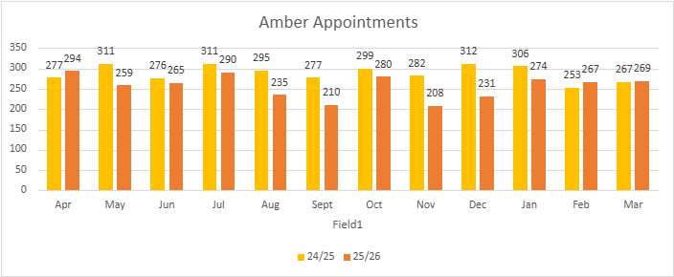

The data shows that in 2024/25 we had 8622 appointments in total. In 2025/26 we had 8630 appointments in total. This demonstrates that the practice has not reduced the number of overall appointments. There were more green appointments in 2025/26, as we were flexing the appointment book to ensure the availability of amber and green appointments met with need/demand. Having more green appointments will increase waiting times, as these are routine cases.

The practice list size has remained stable, meaning we are not looking after additional patients. Subjectively, we have felt that demand for appointments has increased in recent times. The practice has the appropriate quota of GP’s for the corresponding list size.

